AUTHOR NOTES
I think this chapter is worth expanding, but not by adding more generic cybersecurity theory. It needs a few targeted supporting topics so the chapter becomes a complete “policy delivery and directory data” terrain chapter, not just a collection of Group Policy Object (GPO), SYSVOL, and NTDS.dit facts.
The current chapter already fits the 48-chapter charter. Chapter 7 is officially supposed to cover Policy Delivery and Directory Data: Group Policy, SYSVOL, and NTDS.dit, with GPO/SYSVOL delivery and the directory data stored treated as terrain. The outline also aligns with Active Directory assessment practice: assessment material commonly reviews SYSVOL/Group Policy, name resolution, Domain Controller health, Active Directory database information, account information, operational dependencies, disaster recovery, backups, change configuration/change management, and integrated services.
My recommendation: keep the chapter, but tighten its spine.
The actual theme should be:
Group Policy tells the enterprise what to do. SYSVOL carries that policy. NTDS.dit records the identity authority that makes the policy actionable and meaningful. Together, they form a connected domain-control surface.
That framing makes the chapter coherent.
Main Issue with Current Outline
The chapter is strong, but it is currently doing three things at once, in my opinion:
First, it teaches Group Policy operations.
Second, it teaches SYSVOL as the file-based policy delivery layer.
Third, it teaches NTDS.dit as the directory database and identity data store.
That combination is valid for Chapter 7, but only if we clearly tell the reader why those three belong together. Otherwise, GPO and NTDS.dit (as it did for me) feel like two separate chapters forced into one.
So, it needs supporting topics – mostly connective tissue, not massive new content.
What I Suggest To Add
Add a short section after 7.1
I would add:
7.1.1 Policy Delivery and Directory Data as Domain Control Surfaces
This should explain that Active Directory Domain Services (AD DS) controls the enterprise through two major mechanisms: directory authority and policy enforcement. NTDS.dit stores the authoritative directory data. Group Policy defines enforced configuration. SYSVOL distributes the file-based policy material that clients retrieve and apply.
This gives the reader the “why” before we dive into mechanics.
Suggested paragraph:
Active Directory Domain Services (AD DS) controls an enterprise through both identity data and policy delivery. NTDS.dit stores the authoritative directory database that defines users, computers, groups, credentials, relationships, and permissions. Group Policy Objects (GPOs) define how domain-joined users and computers should be configured. SYSVOL carries the file-based policy templates, scripts, and supporting content that allow those policies to reach clients. These components are often discussed separately, but operationally they work together: the directory defines what exists and what is trusted, while Group Policy defines how trusted systems and users are configured.
Add GPO Architecture Before Daily Issues
I added a new section topic about Daily GPO Issues. Before it, we need a technical anatomy section. Right now, the chapter jumps from “what Group Policy is” into daily issues before fully explaining how a GPO is built.
Add:
7.4.1 The Two Halves of a GPO: Group Policy Container and Group Policy Template
This is critical. A GPO is not just “a policy.” It has an Active Directory side and a SYSVOL side.
The Group Policy Container (GPC) lives in Active Directory and stores metadata such as the GPO name, globally unique identifier, version information, status, and links.
The Group Policy Template (GPT) lives in SYSVOL and stores the file-based policy contents, scripts, administrative template settings, security templates, and preference files.
This section will also make our later SYSVOL section stronger because the reader will already understand why SYSVOL matters.
Suggested insertion:
A Group Policy Object (GPO) has two major components: the Group Policy Container (GPC) and the Group Policy Template (GPT). The GPC exists in Active Directory and stores metadata about the policy, including its identity, version, status, and linkage. The GPT exists in SYSVOL and contains the file-based policy content that clients retrieve during processing. This split is one reason Group Policy troubleshooting can become confusing: a policy may appear correctly in Active Directory while its SYSVOL contents are missing, stale, inconsistent, or unavailable on one or more Domain Controllers.
Add GPO Scope, Filtering, and Precedence as Its Own Section
We already have 7.3 Core Principles and 7.5.2.7 Policy Inheritance Misunderstandings, but the mechanics deserve their own structured explanation.
Add after 7.4:
7.4.2 Scope of Management
7.4.3 Link Order and LSDOU Processing
7.4.4 Security Filtering and WMI Filtering
7.4.5 Enforced GPOs and Blocked Inheritance
7.4.6 Loopback Processing
This prevents the daily troubleshooting section from having to explain foundational mechanics while also discussing operational problems.
Add Default Domain Policy and Default Domain Controllers Policy
This is missing and should absolutely be included.
Add under Group Policy architecture or Group Policy features:
7.6.6 Default Domain Policy and Default Domain Controllers Policy
This matters because those two policies are frequently misunderstood, modified carelessly, or overloaded. In federal environments, this is especially relevant because baseline settings, account policy, Kerberos policy, audit policy, user rights, and Domain Controller security expectations often intersect here.
Suggested paragraph:
Two default Group Policy Objects deserve special attention: the Default Domain Policy and the Default Domain Controllers Policy. The Default Domain Policy commonly contains domain-wide account policy settings, including password policy, account lockout policy, and Kerberos-related policy. The Default Domain Controllers Policy applies to the Domain Controllers organizational unit and affects systems that sit at the center of Tier 0 authority. These policies should not become dumping grounds for unrelated configuration. Changes to either policy can affect authentication behavior, administrative control, auditability, and domain-wide security posture.
Add Central Store / ADMX / ADML Support
We mention Administrative Template Settings (ADMX), but this needs support.
Add:
7.6.5.1 The Central Store for Administrative Templates
7.6.5.2 ADMX and ADML Version Drift
This is an everyday problem and a good bridge to SYSVOL because the Central Store lives under SYSVOL.
Suggested paragraph:
Administrative Template (ADMX) files define registry-based policy settings exposed through Group Policy management tools. In domain environments, agencies commonly maintain a Central Store in SYSVOL so administrators use a consistent set of templates. If the Central Store is missing, outdated, partially updated, or inconsistent, administrators may see different policy settings depending on the workstation used to edit the GPO. This creates both operational confusion and configuration drift, especially when Windows versions, server versions, Microsoft Edge templates, Office templates, security baseline templates, or vendor-provided templates are updated unevenly.
Add Group Policy Change Control and Auditability
This is important for our federal/DoD angle.
Add:
7.8.1 GPO Change Control
7.8.2 GPO Backup and Restore
7.8.3 GPO Versioning and Review Evidence
7.8.4 GPOs as RMF / ATO Evidence
We do not need to turn this into another chapter, but we should introduce it here because GPOs are often used as evidence that controls are implemented.
Suggested paragraph:
In federal and defense environments, Group Policy is not only an administrative mechanism; it is also evidence. A GPO may demonstrate that a security baseline, audit requirement, logon restriction, firewall rule, credential protection setting, or user-rights assignment has been technically implemented. That evidence is only reliable when GPO ownership, change control, backup, version history, scope, and effective application can be demonstrated. A policy that exists but is not linked, not applied, not replicated, or overridden by another policy does not satisfy the control objective in practice.
Add a Hybrid GPO / Intune / MDM Section
This chapter should include a short hybrid section. Since Chapter 6 owns broader hybrid identity services and Chapter 46 owns hybrid defense, Chapter 7 should only discuss policy coexistence.
Add near the end of the GPO portion, before SYSVOL:
7.8.5 Group Policy in Hybrid Environments
Suggested subsection structure:
7.8.5.1 Traditional GPO Management
7.8.5.2 Microsoft Intune and Mobile Device Management Policies
7.8.5.3 Hybrid Microsoft Entra Joined Devices
7.8.5.4 Policy Conflict Between GPO and MDM
7.8.5.5 Gradual Migration from GPO to Cloud-Native Policy
Suggested paragraph:
Hybrid environments rarely eliminate Group Policy immediately. Instead, traditional Group Policy often continues to manage domain-joined Windows settings while Microsoft Intune, Mobile Device Management (MDM), and Microsoft Entra ID manage cloud-facing device compliance, application deployment, conditional access support, and modern endpoint configuration. This coexistence can create policy overlap, conflict, and migration risk. A setting may be controlled by GPO on one device, by Intune on another, or by both on a hybrid-joined endpoint. The security question is not whether GPO or MDM is “better,” but whether the agency can prove which authority controls each setting, which devices are in scope, which policy wins during conflict, and how the migration preserves baseline enforcement.
Add a Troubleshooting Workflow Section
We already have daily issues, but the chapter needs a clean operational workflow after them.
Add after 7.5.3 Operational and Security Takeaway:
7.5.4 Group Policy Troubleshooting Workflow
Suggested subpoints:
7.5.4.1 Confirm Object Location
7.5.4.2 Confirm GPO Link and Scope
7.5.4.3 Confirm Security Filtering and WMI Filtering
7.5.4.4 Confirm Client-Side Extension Processing
7.5.4.5 Confirm SYSVOL and NETLOGON Accessibility
7.5.4.6 Confirm Active Directory and DFSR Replication Health
7.5.4.7 Confirm Effective Policy Using gpresult / RSoP / GPMC Modeling
This would make the daily-issues section much more practical.
Add SYSVOL Integrity and Permission Review
Our SYSVOL section already has structure, but it should include:
7.9.3 SYSVOL Permissions and Integrity
7.9.4 Scripts, Startup Files, and Logon Files in SYSVOL
7.9.5 Group Policy Preferences and Legacy Password Exposure
7.9.6 SYSVOL Monitoring and Change Detection
This is necessary because SYSVOL is not only replication plumbing. It is a policy distribution path, a script distribution path, and historically a place where sensitive material has been exposed. Your source material explicitly flags “Passwords in SYSVOL & Group Policy Preferences” and “Exploit Group Policy Objects GPO” as known Active Directory attack topics, so Chapter 7 should introduce the risk as terrain without turning it into an exploitation walkthrough.
Suggested paragraph:
SYSVOL should be treated as a policy delivery surface and a security-sensitive file distribution path. Logon scripts, startup scripts, Group Policy Preferences, administrative templates, and policy files stored in SYSVOL may influence large numbers of domain-joined systems. If SYSVOL permissions are too broad, if legacy preference files contain sensitive data, if scripts are modified without authorization, or if replication distributes malicious or outdated content, the domain can enforce the wrong behavior at scale. For this reason, SYSVOL integrity, permissions, replication health, and change monitoring are core identity-security concerns.
Rework the NTDS.dit Section to Stay “Terrain,” Not Attack Execution
Our NTDS.dit section is good, but 7.13 currently risks drifting into Chapter 29 territory because it names Volume Shadow Copy Service, offline extraction, and Directory Replication Service replication / DCSync.
Since Chapter 29 is the Domain Dominance capstone and officially owns NTDS.dit, DCSync, DCShadow, KRBTGT, Golden Tickets, rogue Certificate Authority / federation, and related dominance topics, Chapter 7 should treat those as conceptual future-risk previews, not operational attack sections.
So I would revise:
Current:
7.13 The Volume Shadow Copy Service (VSS)
7.13.1 Offline Extraction
7.13.2 DCSync Replication
7.13.3 Domain Replication and the Distributed Nature of NTDS.dit
Better:
7.13 Why NTDS.dit Cannot Be Treated as an Ordinary Database
7.13.1 Live Database Locking and Domain Controller Operation
7.13.2 Backup, Snapshot, and Recovery Exposure
7.13.3 Replication Rights and the Distributed Nature of Directory Secrets
7.13.4 Why Detailed Extraction and Replication Abuse Are Deferred to Chapter 29
That keeps Chapter 7 clean. It teaches why the database matters without teaching the attack mechanics too early.
Compress 7.15.1 and 7.15.2
This section is currently too generic:
7.15.1 Defining the Concepts of the Cyber Security Vulnerability, Threat, and Risk Attack Surface
7.15.2 The Three Main Components of an Attack Surface
7.15.2.1 Digital Attack Surface
7.15.2.2 Physical Attack Surface
7.15.2.3 Social Engineering (Human) Attack Surface
7.15.2.4 Attack Surface Management
I would not spend much chapter space here. It is generic and belongs better in Chapter 9 assessment / baseline engineering. In this chapter, replace it with a focused section:
7.15 Group Policy, SYSVOL, and NTDS.dit as Connected Attack Surface
Then use:
7.15.1 Policy Attack Surface
7.15.2 File-Based Policy Delivery Attack Surface
7.15.3 Directory Database Attack Surface
7.15.4 Delegation and Permission Attack Surface
7.15.5 Replication and Backup Attack Surface
7.15.6 Assessment Questions for GPO, SYSVOL, and NTDS.dit
That keeps it chapter-specific.
Clean Revised Expansion Map
Here is how I would revise the structure without blowing it up:
7.1 The Two Pillars of Domain Control
Add: policy delivery + directory data as domain control surfaces.
7.2 Overview of Group Policy Objects (GPOs)
Good.
7.3 Core Principles of Group Policy
Good, but avoid turning this into generic security principles. Tie each principle to GPO behavior.
7.4 What Group Policy Actually Is
Add GPC/GPT, scope, links, filtering, inheritance, loopback, and processing order.
7.5 Daily-Basis Issues with Group Policy Objects
Good. Add a troubleshooting workflow after the daily issues.
7.6 Group Policy Features
Good. Add Default Domain Policy, Default Domain Controllers Policy, Central Store, ADMX/ADML drift.
7.7 Group Policy Processing and Client-Side Extensions (CSEs)
Good. Add foreground/background processing, synchronous/asynchronous processing, refresh intervals, slow-link behavior, and client-side extension failure modes.
7.8 GPO Permissions and the Delegation Model
Good. Add change control, auditability, backup/restore, and federal evidence relevance.
7.8.5 Group Policy in Hybrid Environments
New. Include Microsoft Intune, Mobile Device Management, Microsoft Entra ID, hybrid-joined devices, policy conflict, and migration from GPO to MDM.
7.9 SYSVOL: The File System That Carries Domain Policy
Good. Add permissions, integrity monitoring, scripts, legacy Group Policy Preferences exposure, SYSVOL/NETLOGON health, and DFSR monitoring.
7.10 NTDS.dit: What It Is, What It Means, and Why Everything Depends On It
Good. Keep as terrain.
7.11 supplementalCredentials and Kerberos Key Material
Good, but keep conceptual. Do not go too deep into extraction.
7.12 The ESE Lock and Live Database Access
Good.
7.13 NTDS.dit Backup, Snapshot, and Replication Exposure
Reframe away from “how to extract” and toward “why backup/snapshot/replication pathways matter.”
7.14 NTDS.dit in the Context of the Federal Identity Trust System
Excellent. Keep.
7.15 Group Policy, SYSVOL, and NTDS.dit as Connected Attack Surface
Rebuild this section around the chapter’s three objects, not generic attack surface theory.
7.16 Assessment and Validation Questions
New. Add practical questions an assessor, Information System Security Officer (ISSO), engineer, or defender should ask.
7.17 Summary and Transition
Renumber from current 7.16.
Best Supporting Tables to Add
I would add these tables:
Table 7-1. Group Policy Object Components: GPC versus GPT
Columns: Component, Location, Purpose, Security Concern, Failure Mode.
Table 7-2. GPO Scope and Precedence Controls
Columns: Control, Function, Common Mistake, Security Impact.
Table 7-3. Daily GPO Troubleshooting Symptoms and Likely Causes
Columns: Symptom, Likely Cause, Validation Method, Security Impact.
Table 7-4. SYSVOL Contents and Security Relevance
Columns: Content Type, Purpose, Risk, Monitoring Requirement.
Table 7-5. NTDS.dit Internal Data Categories
Columns: Data Category, Meaning, Why It Matters, Later Attack Relevance.
Table 7-6. Connected Attack Surface: GPO, SYSVOL, and NTDS.dit
Columns: Component, Normal Function, Abuse Potential, Defensive Control, Later Chapter.
Table 7-7. Federal Assessment Questions for Policy and Directory Data
Columns: Assessment Area, Question, Evidence Source, Mission Impact.
Best Figures to Add
Figure 7-1. The Two Pillars of Domain Control: Policy Delivery and Directory Data
Shows GPO/SYSVOL on one side, NTDS.dit/Domain Controllers on the other.
Figure 7-2. Anatomy of a GPO: GPC in Active Directory and GPT in SYSVOL
This is necessary.
Figure 7-3. Group Policy Processing Flow: Local, Site, Domain, OU
Include filtering, inheritance, enforcement, and client-side extensions.
Figure 7-4. SYSVOL Replication and Policy Distribution Path
Shows Domain Controllers, Distributed File System Replication (DFSR), clients, and policy retrieval.
Figure 7-5. NTDS.dit as Authoritative Directory Data
Shows users, groups, computers, credentials, links, security descriptors, and replication.
Figure 7-6. Connected Attack Surface: GPO, SYSVOL, NTDS.dit
This can become the chapter’s main visual.
Figure 7-7. Group Policy in a Hybrid Environment
This will show: on-premises AD DS with GPOs, Microsoft Entra ID, Intune / MDM, hybrid-joined devices, and migration from GPO to cloud-native policy.
Final Judgment
The chapter does not need a major expansion in every direction. It needs better scaffolding.
Keep the current content, but add:
GPC/GPT anatomy.
Scope, filtering, precedence, and loopback.
Default policies.
Central Store / ADMX / ADML drift.
GPO change control and federal evidence value.
Hybrid GPO / Intune / MDM coexistence.
SYSVOL permissions, scripts, and integrity monitoring.
NTDS.dit as terrain, not attack execution.
A focused connected-attack-surface section.
Assessment and validation questions.
The one thing I would definitely remove or compress is the broad “digital / physical / social engineering attack surface” section. It is not wrong, but it dilutes Chapter 7. This chapter should stay tightly centered on policy delivery, SYSVOL, and directory data as domain-control terrain.
PROPOSED REFRAMED CHAPTER 7 TABLE OF CONTENTS: KEEPS ORIGINAL MATERIAL, BUT REORGANIZED IT AROUND STRONGER CHAPTER THESIS OF GROUP POLICY DEFINES ENFORCED CONFIGURATION, SYSVOL CARRIES POLICY CONTENT, NTDS.DIT STORES AUTHORITATIVE IDENTITY DATA AND TOGETHER THEY FORM A CONNECTED DOMAIN-CONTROL SURFACE
======================================================
  - The Two Pillars of Domain Control
    - Directory Authority and Policy Enforcement
    - Policy Delivery and Directory Data as Control Surfaces
    - Why Group Policy, SYSVOL, and NTDS.dit Belong Together
    - Group Policy, Directory Data, and the Federal Identity Trust System
    - Operational Risk When Policy and Directory Authority Drift Apart
  - Overview of Group Policy Objects
    - What Group Policy Objects Are Designed to Control
    - User Configuration Versus Computer Configuration
    - Local Policy Versus Domain-Based Policy
    - Group Policy in Administrative Operations
    - Group Policy as Security Control Enforcement
    - Group Policy as Evidence in Federal and Defense Environments
  - Core Principles of Group Policy
    - Centralized Control
    - Principle of Least Privilege
    - Consistency
    - Automation
    - Security Enhancement and Enforcement
    - Security Compliance
    - Predictability and Measurability
    - Mission Continuity and Operational Reliability
  - What Group Policy Actually Is
    - The Two Halves of a Group Policy Object: Group Policy Container (GPC) and Group Policy Template (GPT)
    - Group Policy Container Metadata in Active Directory
    - Group Policy Template Content in SYSVOL
    - Gorup Policy Links and Scope of Management
    - Local, Site, Domain, and Organizational Unit (OU) Processing Order: LSDOU
    - Link Order and Policy Precedence
    - Security Filtering
    - Windows Management Instrumentation (WMI) Filtering
    - Enforced Group Policy Objects and Blocked Inheritance
    - Loopback Processing
    - Resultant Set of Policy (RSoP) and Effective Policy
    - Intended Policy Versus Applied Policy
  - Daily Operational Issues with Group Policy Objects
    - Group Policy Object Configurations Not Applying to User or Computer Containers
    - Group Policy Object-Contributing Factors to Host- and Network-Based Slowness and Latency
      - Slow Logon Times Due to Large or Excessive Group Policy Objects
      - Incorrect Organizational Unit (OU) Placement
      - Conflicting and Inconsistent Group Policy Object Settings
      - Domain Name System (DNS) and Active Directory Domain Replication Issues
      - Domain Controller Availability and Health Issues
      - SYSVOL Replication Problems
      - Policy Inheritance Misunderstandings
      - Slow Links, Remote Sites, and Network Path Quality
    - Operational and Security Takeaway
    - Group Policy Troubleshooting Workflow
      - Confirm User and Computer Object Location
      - Confirm Group Policy Object Link and Scope
      - Confirm Security Filtering and Windows Management Instrumentation (WMI) Filtering
      - Confirm User-Side and Computer-Side Policy Status
      - Confirm Client-Side Extension Processing
      - Confirm SYSVOL and NETLOGON Availability
      - Confirm Active Directory and Distributed File System Replication (DFSR) Health
      - Confirm Effective Policy Using Group Policy Results, Resultant Set of Policy (RSoP), Group Policy Management Console (GPMC) Modeling, and the Microsoft Group Policy Analyzer
  - Group Policy Features
    - Security Settings
    - Software Deployment
    - Script Execution
    - Registry Configuration
    - Administrative Template Settings
      - Administrative Template Files (ADMX)
      - Administrative Template Language Files
      - The Central Store for Administrative Templates
      - Administrative Template Version Drift
    - Group Policy Preferences (GPP)
    - Default Domain Policy
    - Default Domain Controllers Policy
    - Security Baseline Implementation
    - Mission-Specific Policy Exceptions
  - Group Policy Processing and Client-Side Extensions (CSE)
    - Foreground Processing at Startup and Logon
    - Background Policy Refresh
    - Synchronous Versus Asynchronous Processing
    - Slow-Link Detection
    - User-Side Processing
    - Computer-Side Processing
    - Client-Side Extension Behavior
    - Client-Side Extension Failure Modes
    - Group Policy Operational Logging
    - Group Policy Processing in Remote, Segmented, and Mission Environments
  - Group Policy Object Permissions, Delegation, and Change Governance
    - Group Policy Object Ownership
    - Group Policy Object Permissions
    - Delegated Editing Rights
    - Who Can Link, Edit, Read, Apply, Delete, or Modify a Group Policy Object
    - Delegation Mistakes That Create Additional Attack Pathways
    - Group Policy Object Change Control
    - Group Policy Object Backup and Restore
    - Group Policy Object Versioning
    - Group Policy Object Review Evidence for the Risk Management Framework (RMF) and Authorization to Operate (ATO)
    - Group Policy Object Availability and Accountability
    - Separation of Duties in Policy Administration
  - Group Policy in Hybrid Environments
    - Traditional On-Premises Active Directory Domain Services (AD DS) with Group Policy Objects
    - Microsoft Entra ID and Cloud Identity Governance
    - Microsoft Intune and Mobile Device Management (MDM)
    - Hybrid Microsoft Entra-Joined Devices
    - Group Policy Object Authority Versus Mobile Device Management Authority
    - Policy Conflict and Precedence in Hybrid Management
    - Gradual Migration from Group Policy Objects to Cloud-Native Policy
    - Federal and Defense Considerations for Hybrid Policy Control
  - SYSVOL: The File System That Carries Domain Policy
    - What SYSVOL Stores
    - SYSVOL Structure
      - Policies Folder
      - Scripts Folder
      - NETLOGON Share
    - SYSVOL and Group Policy Template (GPT) Processing
    - File Replication Service (FRS) and Distributed File System Replication (DFSR)
      - File Replication Service
      - Distributed File System Replication
      - File Replication Service-to-Distributed File System Replication Migration Risk
    - SYSVOL Permissions and Integrity
    - Scripts, Startup Files, and Logon Files in SYSVOL
    - Group Policy Preferences (GPP) and Legacy Password Exposure
    - SYSVOL Replication Health
    - SYSVOL Monitoring and Change Detection
    - SYSVOL as an Attack Surface
  - NTDS.dit: What It Is, What It Means, and Why Everything Depends On It
    - Dissecting the Naming of the NTDS.dit Database File
    - The Extensible Storage Engine (ESE)
    - NTDS.dit as Authoritative Directory Data
    - The Tables Inside NTDS.dit
      - The Data Table
      - The Link Table
      - The Security Descriptor Table
    - Object Relationships and Identity Meaning
    - Why NTDS.dit Is Not an Ordinary Database
  - Credential and Kerberos Key Material in the Directory Database
    - How Password Material Is Represented Conceptually
    - Layer 1 – The Raw Hash
    - Layer 2 – The Password Encryption Key (PEK)
    - Layer 3 – The System Boot Key
    - supplementalCredentials and Kerberos Key Material
    - Managed Service Accounts and Group Managed Service Accounts (gMSA)
    - Why Detailed Extraction Techniques Are Deferred to the Domain Dominance Chapter
  - Live Database Behavior, Backup, Snapshot, and Replication Exposure
    - The Extensible Storage Engine (ESE) Lock and Live Database Access
    - Volume Shadow Copy Service (VSS) as a Backup and Snapshot Dependency
    - Offline Copies as Protection and Exposure
    - Domain Replication and Distributed Identity Data
    - Replication Rights and Directory Secrets
    - Why Replication Abuse Is Treated Later as Domain Dominance
  - NTDS.dit in the Context of the Federal Identity Trust System
    - Authoritative Identity Data
    - Tier 0 Dependency
    - Credential and Assurance Implications
    - Mission Partner and Federation Consequences
    - Recovery and Trust Restoration Implications
  - Group Policy, SYSVOL, and NTDS.dit as Connected Attack Surface
    - Policy Attack Surface
    - File-Based Policy Delivery Attack Surface
    - Directory Database Attack Surface
    - Delegation and Permission Attack Surface
    - Replication and Backup Attack Surface
    - Hybrid Policy Attack Surface
    - How Group Policy, SYSVOL, and NTDS.dit Fail Together
    - Defensive Control Points
  - Assessment and Validation Questions
    - Group Policy Object Scope and Application Validation
    - Group Policy Object Permission and Delegation Review
    - SYSVOL Replication and Integrity Validation
    - NTDS.dit Protection and Backup Review
    - Domain Controller Security and Tier 0 Validation
    - Hybrid Policy Management Review
    - Evidence Required for Information System Security Officers, Information System Security Managers, the Risk Management Framework, and Authorization to Operate Packages
    - Mission Impact Questions
  - Summary and Transition
    - Key Concepts Reviewed
    - Why Policy Delivery and Directory Data Matter to Domain Control
    - Why Group Policy Must Be Validated, Not Assumed
    - Why SYSVOL Integrity Matters to Enterprise Enforcement
    - Why NTDS.dit Represents Identity Authority
    - Transition to Chapter 8: The Global Catalog and Cross-Domain Directory Services
======================================================

CHAPTER 7.

POLICY DELIVERY AND DIRECTORY DATA: GROUP POLICY, SYSVOL, AND NTDS.DIT

ABSTRACT
Active Directory governs two distinct but inseparable categories of infrastructure: the policy that tells every domain-joined system how to behave, and the data that tells the directory who every principal is and what they are permitted to do.
Chapter 7 examines both. Group Policy is the mechanism through which configuration, security settings, software deployment, and administrative controls flow from domain controllers to every workstation, server, and user session in the enterprise. SYSVOL is the shared file system that carries Group Policy Objects (GPOs) and logon scripts across the domain, replicated among domain controllers through the File Replication Service (FRS) or the Distributed File System Replication (DFSR) engine. The NTDS.dit file is the Extensible Storage Engine (ESE) database file that is Active Directory – every identity, every credential, every relationship, every attribute in the domain stored in a single structured file on every domain controller. Together, these three components represent some of the most valuable and most attacked infrastructure in a Windows environment. An adversary who controls Group Policy controls every domain-joined system. An adversary who extracts NTDS.dit holds every credential in the domain. This chapter examines how each component works, how it is structured, and why its integrity is foundational to the identity trust system examined throughout this book.

KEYWORDS
Group Policy (GP); Group Policy Objects (GPO); SYSVOL; NTDS.dit; Extensible Storage Engine (ESE); Directory Information Tree; Credential storage; Domain Controller (DC); Password expiration key

KEY TERMS
- Group Policy Object (GPO): A collection of policy settings stored in Active Directory and on SYSVOL that defines configuration and security requirements applied to users and computers that are joined to a domain.
- Group Policy Container (GPC): The Active Directory object in the domain partition that stores a GPOs metadata, version number, and links.
- Group Policy Template (GPT): The file system component of a GPO stored in SYSVOL, containing policy settings, domain and endpoint scripts, and associated files.
- SYSVOL: A shared directory tree replicated among all domain controllers in a domain, hosting Group Policy Templates, logon scripts, and other domain-wide files.
- File Replication Service (FRS): The legacy Windows service that replicates SYSVOL content among domain controllers, deprecated and replaced by DFSR.
- Distributed File System Replication (DFSR): The modern replication engine that replaced FRS for SYSVOL replication, providing more efficient and reliable content synchronization among domain controllers.
- NTDS.dit: The Active Directory database file – New Technology Directory Services, Directory Information Tree – stored on every domain controller and containing the complete directory data for the domain.
- Extensible Storage Engine (ESE): The transactional database engine underlying NTDS.dit also used by Microsoft Exchange SMTP (Simple Mail Transfer Protocol) Server and other Microsoft products.
- Password Encryption Key (PEK): A domain-unique symmetric key used to encrypt password hash values stored in NTDS.dit, itself encrypted with the SYSTEM boot key.
- SYSTEM Hive: The registry hive containing the boot key (SYSKEY) used to encrypt the PEK, required alongside NTDS.dit to extract usable credential data.
- Volume Shadow Copy Service (VSS): The Windows infrastructure that creates point-in-time snapshots of volumes, commonly used to extract a copy of NTDS.dit from a live domain controller without taking the file system offline.

7.1 THE TWO PILLARS OF DOMAIN CONTROL
Every domain controller in an Active Directory environment is simultaneously responsible for two distinct categories of critical data. The first is configuration authority – the policies, settings, scripts, and controls that determine how every domain-joined system behaves, what software it runs, what security settings it enforces, and what users can and cannot do. The second is identity authority – the structured record of every principal in the domain, their credentials, their group memberships, their permissions, their relationships, and their history. These two categories are carried by different mechanisms, stored in different places and replicated through different systems. But they share one fundamental property: whoever controls them controls the domain.
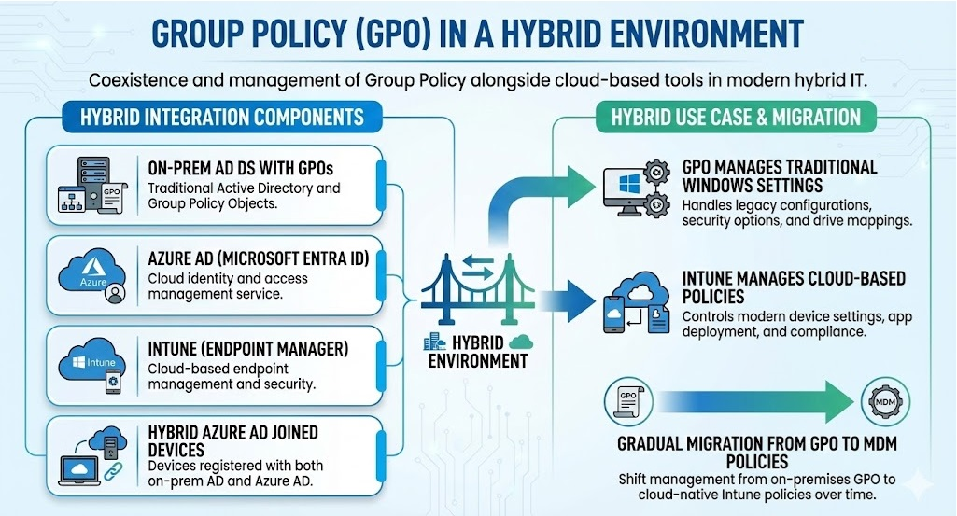
Group Policy and SYSVOL carry the configuration authority. NTDS.dit carries the identity authority. Neither is more important than the other, and both are attractive attack targets of the highest order. This chapter examines how each works at the structural level – not because the mechanics are interesting for their own sake, but because understanding how they work is the prerequisite for understanding how they fail, how they are attacked, and how those attacks are detected and defended.
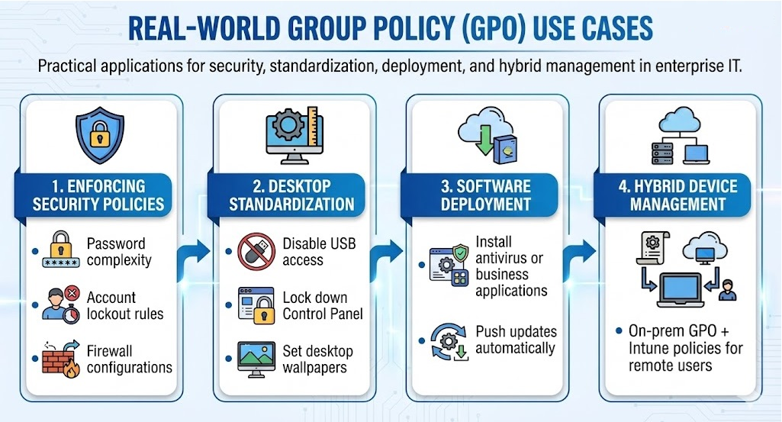
If you are an IT professional who has never used Group Policy Object (GPO) to control computer configurations, this chapter is for you. Group Policy Objects are the essential way that most commercial organizations and federal and military agencies and branches enforce security settings on their users, services, applications, but mostly on their computers and servers. It is flexible enough for even the most complex scenarios; however,

OVERVIEW OF GROUP POLICY
Group Policy Object functionalities provide the easiest way to reach out and configure computer and user settings on networks based on Active Directory Domain Services (AD DS). If an agency is not using Group Policy Object deployments to enforce even the most simplest security settings to setting a computer idle lockout period to completely blocking internet access, revoking/restricting and removing permissions as well as adding them, patching of applications and workstations and servers GPO can deploy, then you are missing a huge opportunity to reduce total overhead costs, control configurations are better controlled and managed via GPO vice not, keep users productive and happy, and compliant.
Group Policy essentially tells the enterprise what to do. SYSVOL carries that policy. NTDS.dit records the identity authority that makes the policy actionable and meaningful, and, together, they form a connected domain-control surface.
Think of Group Policy as “touch once, configure many.”
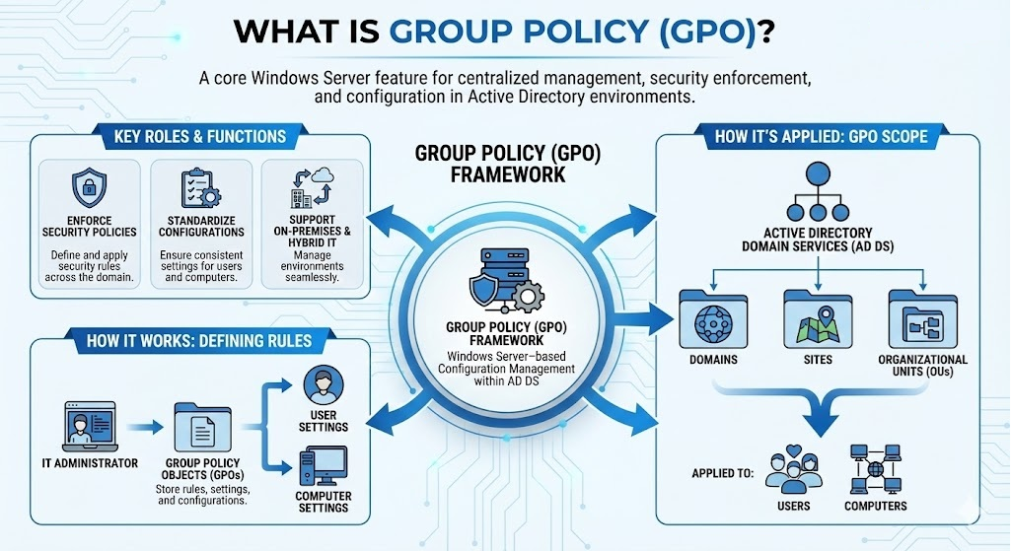
The requirements for Group Policy to be established are dependent on key component parts of the entire Active Directory pie:
- The network must be based on AD DS (that is, at least one server must have the AD DS role installed).
Computers that you want to manage must be joined to the domain, and users that you want to manage must use legitimate, authorized credentials to log on to their computers.
You must have permissions to edit Group Policy in the domain.

7.2 CORE PRINCIPLES OF GROUP POLICY
Group Policy is the mechanism through which an Active Directory domain administrator can define a configuration requirement once and have it automatically applied to thousands of machines and user sessions. It is one of the most powerful features of Windows domain management and, predictably, one of the most powerful levers an adversary seeks to control.
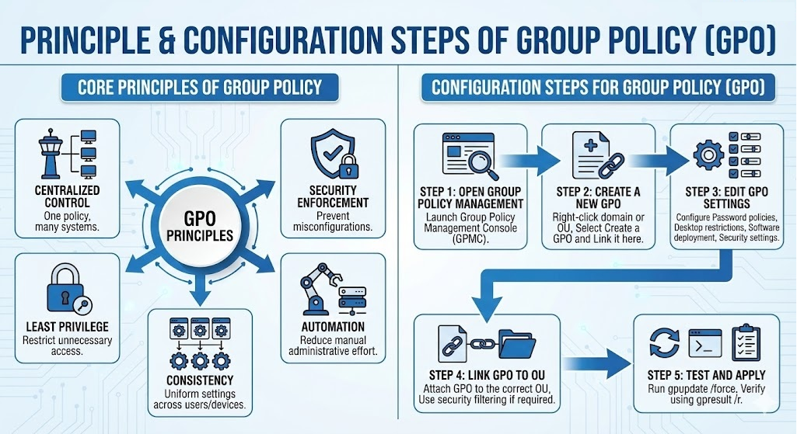

7.2.1 WHAT GROUP POLICY ACTUALLY IS
Group Policy is not a single object or a single file. It is a two-part system. The policy settings, metadata, and version information are stored as an object in Active Directory – the Group Policy Container (GPC). The actual configuration content, scripts, templates, and associated files are stored on SYSVOL – the Group Policy Template (GPT). When a Group Policy Object (GPO) is created, both components are created simultaneously, linked together by a common GUID (Globally Unique Identifier). The GPC lives in CN=Policies,CN=System,DC=domain,DC=tld. The GPT lives in \\domain.tld\SYSVOL\domain.tld\Policies\{GUID}. If the two components become out of sync – a common occurrence in poorly maintained environments – Group Policy behaves unpredictably, with some settings applying from stale content and others failing silently.
A GPO is linked to a site, a domain, or an Organizational Unit (OU). When a computer boots or a user logs on, the Group Policy client evaluates which GPOs apply, downloads, and processes the relevant GPTs, and applies the settings. This evaluation follows a defined inheritance order: Local Policy is processed first, then Site GPOs, then Domain GPOs, then OU GPOs from the top of the OU hierarchy down to the OU containing the object. Settings configured at a lower level in the hierarchy override conflicting settings from higher levels, unless the higher-level GPO is enforced – in which case it cannot be overridden. Understanding this inheritance model is essential for both administering policy and for assessing whether a specific setting is actually applying to a specific object.
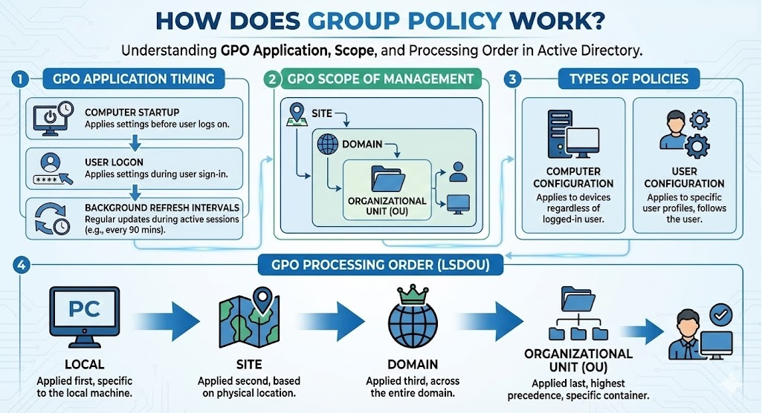

7.2.3 DAILY-BASIS ISSUES WITH GROUP POLICY OBJECTS (GPO)
Group Policy Objects (GPOs) are one of the most powerful administrative control mechanisms in an Active Directory environment. They allow administrators to enforce security settings, configure operating system behaviors, manage complex user environments, deploy software updates and scripts, restrict and allow access, apply security baseline configurations at scale, and standardize inconsistent settings across user and computer Organizational Units (OUs).
In daily operations, however, GPOs are also a frequent source of troubleshooting, confusion, and configuration drift. A policy may not apply. A user may receive the wrong setting. An OU may receive an unwanted inheritance from a parent domain. A workstation may ignore a security baseline, plus more. For a security-related individual, these issues are more than “just a helpdesk issue,” or frequent annoyance. Group Policy is part of the identity control plane. If GPOs do not apply correctly, then password policies, audit policies, firewall settings (both host- and network-based levels), endpoint hardening configurations, administrative restrictions, logon rights and more may not be in a consistent enforced state. In federal and defense environments, that inconsistency can become mission risk or loss of ATO.

7.2.4 GPOs CONFIGURATIONS NOT APPLYING TO USER OR COMPUTER CONTAINERS
One of the most common daily Group Policy problems occurs when a GPO does not apply to the intended user or computer. The administrator may create the policy correctly, link it to what appears to be the correct location, and still find that the target object never received the settings. Spoiler alert: I have accidentally done this before.
This usually happens because Group Policy application depends on several conditions with all being true at the same time. The GPO must be linked to the correct site, domain, or OU. The target user or computer must be located within the scope of that link. The GPO must not be blocked by inheritance rules, denied by security filtering, excluded by Windows Management Instrumentation (WMI) filtering, disabled on either the user or computer side, or overridden by a higher-precedence policy. The client must also be able to reach and communicate with a domain controller, read the Group Policy Container (GPC) , and access the Group Policy Template (GPT) in SYSVOL.
When a GPO does not apply, administrators often see configuration inconsistencies across systems that should be identical. One workstation receives the baseline while another does not. One user receives a mapped network drive while another does not. One server has audit policy enabled while another remains unchanged. These differences may appear small at first, but they can create major operational and security gaps, not to mention frustrations among colleagues and leadership.
The standard troubleshooting approach is to confirm scope first. The administrator should verify that the user or computer object resides in the intended OU, confirm that the GPO is linked to that OU or a parent container, and review whether the GPO is enabled. Next, the administrator should review security filtering to ensure the target identity has permissions to read and apply the GPO. If a WMI filter is attached, the administrator should confirm that the target system actually matches the filtering tools such as Group Policy Results, Resultant Set of Policy (RSoP), gpresult, and the Group Policy Management Console (GPMC) are commonly used to identify what applied, what did not apply, and why.
From a security perspective, failed GPO application is dangerous because administrators may believe a control is enforced when it is not. A baseline that exists in the Group Policy Management Console (GPMC) but does not apply to the intended systems is not a control. It is documentation without enforcement.
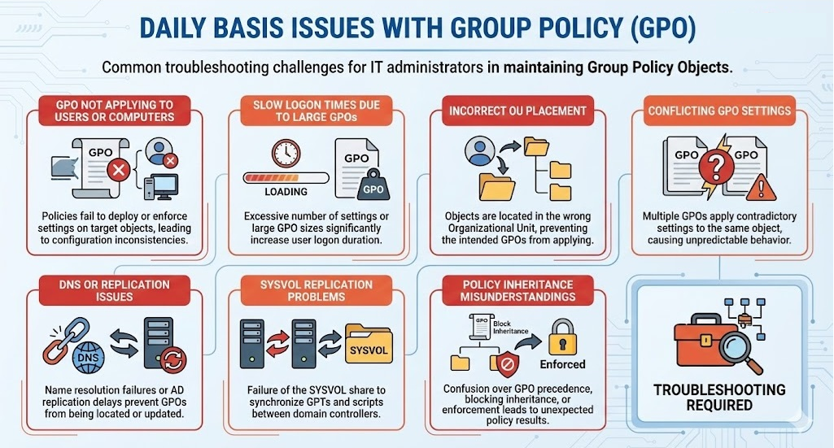

7.2.5 GPO-CONTRIBUTING FACTORS TO HOST- AND NETWORK-BASED SLOWNESS AND LATENCY
Group Policy Objects (GPOs) can contribute to host- and network-based slowness when policy processing becomes too large, too complex, or too dependent on slow infrastructure pathways. Excessive linked policies, large administrative templates, synchronous startup or logon scripts, software deployment settings, network drive mappings, and other contributing factors can immediately increase processing time on the client. Network latency, unavailable domain controllers, slow Domain Name System (DNS) resolution, replication delays, or inconsistent SYSVOL access can further delay policy retrieval and application. In practice, GPO-related slowness is rarely caused by one setting alone; it usually reflects the combined effect of policy design, client performance, domain controller availability, name resolution, replication health, and network path quality.

7.2.5.1 SLOW LOGON TIMES DUE TO LARGE OR EXCESSIVE GPOs
Another frequent operational issue is slow user logon. Group Policy processing occurs during computer startup, user logon, background refresh, and certain network state changes. If the environment contains too many GPOs, overly complex policies, poorly written scripts causing latency and bottlenecks within the system, large GPP items, excessive drive mappings, printer mappings, plus more contribute to host- and network-based sources of slowness.
Slow logons are often treated as a user-experience issue, but they can also become a security and operations issue. When users experience long delays, administrators may be pressured to disable policies, remove scripts, bypass controls, or loosen baseline enforcement. In mission environments, slow logons may delay access to operational systems, shift turnover, command functions, help desk support, or administrative response during an incident.
Large GPOs are not always the problem by themselves. The issue is often cumulative processing burden. A user may receive multiple linked GPOs from the site, domain, parent OU, child OU, and security-filtered policies. Each one may contain settings that must be evaluated. If the policies include synchronous processing, slow network pathways, unavailable domain controllers, software deployment scripts that wait on unavailable resources, or drive mappings to unreachable file shares, the delay can become severe.

Troubleshooting should begin by determining whether the delay occurs during computer startup, user logon, or both. Administrators should review Group Policy operational logs, identify which policies are processing slowly, and examine scripts, drive mappings, printer mappings, software installation settings, and preference items. GPOs should be consolidated where appropriate, but not blindly. Consolidation should reduce processing overhead without destroying clear ownership, auditability, or administrative control.
The security balance matters. A fast logon is not useful if it is achieved by removing required controls. The goal is not simply to reduce the number of GPOs. The goal is to design Group Policy so required controls apply predictably, efficiently, and with minimal operational friction.

7.2.5.2 INCORRECT ORGANIZATIONAL UNIT (OU) PLACEMENT
Incorrect OU placement is one of the simplest and most common causes of Group Policy failure. Because GPOs are commonly linked to OUs, a user or computer placed in the wrong OU may receive the wrong policies or fail to receive required policies.
This happens frequently in environments with complex OU structures, delegated administration, automated provisioning, contractor-managed systems, legacy naming conventions, or inconsistent onboarding processes. A newly imaged workstation may be left in a default container. A server may be placed in a general-purpose OU instead of a hardened server OU. A privileged administrator account may be placed with standard user accounts. A test system may remain in production scope. A mission application server may be moved during troubleshooting and never returned to its intended OU.
The result is policy misalignment. A workstation may miss endpoint hardening. A server may receive user-workstation settings. An administrator may avoid privileged account restrictions. A system may fail to receive audit configuration, firewall policy, User Rights Assignment settings, Local Administrator Password Solution controls, or security baseline enforcement.
Troubleshooting OU placement requires administrators to compare intended design against actual object location. The directory should be reviewed to confirm where users, computers, servers, service accounts, privileged accounts, and administrative workstations are located. Automated join processes, imaging workflows, provisioning scripts, and help desk procedures should also be reviewed because they often determine where objects are created.
In secure environments, OU placement should not be treated as cosmetic organization. OUs define where delegation and policy scope occur. Placing an object in the wrong OU can place it under the wrong administrative control and the wrong security baseline.

7.2.5.3 CONFLICTING OR INCONSISTENT GPO SETTINGS
Conflicting GPO settings occur when multiple policies attempt to configure the same setting differently. One GPO may enable a setting while another disables it. One may configure a password or audit requirement one way while another configures it differently. One may allow a user-based right while another removes it. The result can be confusion, inconsistent behavior, or settings that appear to “randomly” change depending on processing order and precedence.
Group Policy conflict is usually a design and governance problem. Administrators may create new policies to fix immediate issues without checking existing policy structure. Different teams may manage different GPOs. Legacy policies may remain linked after they are no longer needed. Security baselines, mission exceptions, application requirements, and troubleshooting changes may collide. Over time, the Group Policy environment becomes difficult to reason about.
Group Policy precedence follows a defined order: Local, Site, Domain, and then OU, often remembered as LSDOU. When multiple GPOs apply at the same level, link order matters. Enforced GPOs, blocked inheritance, security filtering, WMI filtering, loopback processing, and disabled user or computer settings can further affect results. Because of this, the final setting applied to a user or computer may not be obvious from simply opening one GPO.
Administrators should troubleshoot conflicts using Resultant Set of Policy, Group Policy Results, gpresult, and GPMC modeling. The question is not only “Which policy contains this setting?” but “Which policy wins?” Once the winning policy is identified, the environment should be reviewed for redundant, obsolete, contradictory, or poorly scoped GPOs.
From a security perspective, conflicting GPOs can quietly weaken baselines. A hardening policy may exist, but a later policy may override part of it. A security team may believe a control is enforced, while an application exception GPO silently disables it for a subset of systems. This is why Group Policy review must include effective analysis-driven and results-producing activities to include timely action, not just moving on it to satisfy a policy inventory requirement.

7.2.5.4 DNS AND RELATED ACTIVE DIRECTORY DOMAIN REPLICATION ISSUES
Group Policy depends heavily on Domain Name System (DNS) and Active Directory replication. Clients must locate domain controllers, discover services, read policy objects, and access SYSVOL. If DNS is misconfigured or replication is delayed, broken, or inconsistent, GPO processing may fail or apply outdated settings.
DNS can also contribute to this overall problem by preventing clients from locating the correct domain controller or service records. In Active Directory, Service Locator (SRV) records help clients find domain controllers, Kerberos services, Lightweight Directory Access Protocol (LDAP) services, and other directory-related resources. If those records are missing, stale, incorrectly registered, or pointing to unavailable systems, clients may fail to process Group Policy or may contact a domain controller on an unexpected site.
Replication issues create a different problem. A GPO has components in both Active Directory and SYSVOL. The Group Policy Container exists in Active Directory, while the Group Policy Template exists in SYSVOL. If Active Directory replication has not converged, different domain controllers may have different views of the GPO. A client contacting one domain controller may see one version, while another client contacting a different domain controller may see another.
Operational symptoms may include policies applying inconsistently across sites, new GPOs not appearing everywhere, deleted policies still affecting some systems, clients reporting inaccessible policy paths, or administrators seeing different policy states depending on which domain controller they query.
Troubleshooting should include DNS validation, domain controller health checks, replication status review, site configuration review, and confirmation that clients are contacting appropriate domain controllers. Administrators should verify SRV records, domain controller registration, replication convergence, and client name-resolution behavior.
In federal and defense environments, DNS and replication issues are especially important because geographically distributed networks, segmented enclaves, bandwidth constraints, firewall rules, disconnected operations, and mission partner dependencies may affect which domain controllers clients can reach. A GPO that exists centrally but cannot be located or replicated reliably is not dependable enforcement.

7.2.5.5 SYSVOL REPLICATION PROBLEMS
SYSVOL is the shared directory on domain controllers that stores Group Policy Templates, scripts, and other domain-wide policy files required for Group Policy processing. If SYSVOL does not replicate properly, clients may fail to retrieve policy files even when the GPO appears to exist in Active Directory.
This is a common source of confusion because administrators may see the GPO in the Group Policy Management Console and assume it is available everywhere; however, the visible policy object in Active Directory is only part of the policy. The client also needs the file-based contents stored in SYSVOL. If those files are missing, outdated, or inconsistent across domain controllers, policy application may fail.
Modern environments typically use Distributed File System Replication (DFSR) for SYSVOL replication, while older environments may still have legacy File Replication Service (FRS) dependencies. SYSVOL replication problems may occur because of replication backlog, broken replication membership, permissions issues, disk problems, domain controller health issues, migration problems from FRS to DFSR, or administrative changes made directly in SYSVOL.
Symptoms may include missing scripts, outdated administrative template settings, inconsistent policy application between sites, Group Policy processing errors, or differences in policy files between domain controllers. In some cases, one domain controller may contain the correct GPT while another contains an older version.
Administrators should troubleshoot SYSVOL replication separately from Active Directory replication. Both matter, but they are not the same thing. A healthy Active Directory replication state does not automatically guarantee healthy SYSVOL replication. Administrators should verify SYSVOL and NETLOGON share availability, compare policy folder contents, examine DFSR health, review replication backlog, and confirm that scripts and policy files exist consistently across domain controllers.
It is important to note that SYSVOL replication problems can create baseline drift. Some systems may receive updated security settings while others continue using older configurations. During recovery or incident response, SYSVOL integrity becomes even more important because malicious scripts, unauthorized GPO changes, or inconsistent replication can preserve unwanted behavior.

7.2.5.6 POLICY INHERITANCE MISUNDERSTANDINGS
Group Policy inheritance is powerful but frequently misunderstood. Administrators may expect a policy linked at one level to apply everywhere below it, only to discover that inheritance was blocked, a policy was enforced, security filtering excluded the target, loopback processing changed the result, or a lower-level policy won because of precedence.
Policy inheritance follows the Active Directory hierarchy. GPOs linked at higher levels can flow downward to child OUs; however, administrators can block inheritance at an OU, enforce a GPO so it cannot be overridden in the usual way, filter the GPO so only certain users or computers apply it, or use WMI filtering to apply it only when specific system conditions are met. Loopback processing can also change how user policy applies when users log on to specific computers, such as kiosks, jump boxes, administrative workstations, or Remote Desktop Session Host servers.
Misunderstandings about inheritance often produce unexpected policy results. A security baseline may not apply because inheritance is blocked. An exception policy may override a hardening setting. An enforced policy may apply more broadly than expected. A user may receive different settings depending on which computer they log onto. A privileged workstation may process user settings differently because loopback mode is enabled.
Troubleshooting inheritance requires administrators to evaluate the full policy path, not just the GPO itself. They must examine site, domain, parent OU, child OU, link order, enforcement, blocked inheritance, security filtering, WMI filtering, loopback processing, and whether the user or computer side of the policy is enabled. Group Policy Results and modeling are essential because they show effective policy rather than intended policy.
From a governance perspective, inheritance misunderstandings are dangerous because they create a gap between intended control and actual enforcement. A baseline may be approved, documented, and linked, but still not apply. In mission environments, that gap can become a compliance finding, operational failure, or attack path.

7.2.5.7 OPERATIONAL AND SECURITY TAKEAWAY
Daily Group Policy troubleshooting is not separate from identity security. GPOs enforce many of the controls that protect identities, credentials, administrative boundaries, audit settings, endpoint behavior, logon rights, firewall posture, script execution, local group membership, and security baselines. When Group Policy is inconsistent, the enterprise identity environment becomes inconsistent.
Administrators should treat GPO troubleshooting as control validation. The question is not only whether the policy exists. The question is whether the intended users and computers actually receive it, whether the setting wins against conflicts, whether the policy is replicated correctly, whether SYSVOL contains the correct template files, whether inheritance behaves as expected, and whether the effective configuration supports the agency’s security and mission requirements.
In federal, defense, and mission-partner environments, Group Policy problems should be evaluated through both an operational and security lens. A failed GPO may cause inconvenience. It may also mean audit policy is missing, privileged access restrictions are not enforced, credential protections are absent, firewall settings are wrong, scripts are outdated, or a mission system is operating outside its approved baseline.
A GPO is not security because it exists. A GPO becomes security only when it applies correctly, consistently, and measurably to the intended target.

7.2.6 GROUP POLICY FEATURES
Group Policy is not limited to just desktop backgrounds and password complexity requirements. The scope of what Group Policy can configure is vast, and most practitioners underestimate its full power.

7.2.6.1 SECURITY SETTINGS
Include domain components such as account policies (password complexity, lockout thresholds, Kerberos ticket lifetimes), local policies (user rights assignments, audit policies, security options), the Windows Firewall configuration, software restriction policies (allowlists / denylists), AppLocker rules, credential protection settings (Credential Guard, LSASS protection), and the entire Windows Security configuration baseline. When this book discusses controls like “enforce SMB signing,” “enable LDAP signing,” “enable Credential Guard,” or “configure audit policy” – Group Policy is where you want to be and it is the ultimate delivery mechanism for almost all of them plus more not listed.

7.2.6.2 SOFTWARE DEPLOYMENT
Windows Installer packages can be assigned to computers (installed at startup) or published to users (available for installation). This makes Group Policy a software distribution platform, and, in turn, also makes it a malware distribution platform in the hands of an adversary with write access to the right GPO.

7.2.6.3 SCRIPT EXECUTION
Includes items such as startup scripts, shutdown scripts, logon scripts, and logoff scripts can all be delivered through Group Policy deployments. Scripts configured in a GPO are stored in the GPT on SYSVOL and execute in the machine or user context depending on their type.

7.2.6.4 REGISTRY CONFIGURATIONS
Group Policy Preferences (GPP) allows administrators to configure arbitrary registry values, network and drive mappings, environment variables, scheduled tasks, services, and local users and groups. It was through GPP that one of Active Directory’s most historically significant credential exposures occurred – the `cpassword` vulnerability, covered in Chapter 17.

7.2.6.5 ADMINISTRATIVE TEMPLATE SETTINGS (ADMX)
These are XML-based policy definitions that expose thousands of registry-backed settings for Windows, Office, Internet Explorer/Edge, and any application that ships or supports ADMX templates. Virtually every Windows feature that has a documented Group Policy setting is controlled through an ADMX template.
The breadth of Group Policy’s reach is exactly why it is an attractive prime target. A single GPO linked to the domain root, with no domain user filter, applied with enforcement – that GPO’s settings reach every computer and user in the domain. An adversary who creates or modifies such as GPO has a direct execution pathway, or channel, to every domain-joined system on that network.

7.2.7 GROUP POLICY PROCESSING AND CLIENT-SIDE EXTENSIONS (CSE)
Group Policy processing on the client-side is handled by a set of Client-Side Extensions (CSEs) – Dynamic Link Libraries (DLLs) registered in the registry that each handle a specific category of policy. When the Group Policy client processes a GPO, it passes each section of the policy to the appropriate CSE. The Security extension handles security settings. The Registry extension handles administrative template registry values. The Scripts extension handles startup/shutdown/logon/logoff scripts, and the Software Installation extension handles MSI deployments.
CSEs are triggered at two primary events: computer startup (machine policy processing) and user logon (user policy processing). Between these events, Group Policy refreshes in the background approximately every 90 minutes, with a randomized offset of up to 30 minutes to prevent all machines from contacting domain controllers simultaneously. Domain Controllers themselves refresh every 5 minutes. Security settings are always reapplied at each refresh, even if the GPO version has not changed. Most other settings are only reprocessed if the GPO version number has incremented – though this behavior can be overridden by enabling the setting “Process even if the Group Policy Objects have not changed.”
A significant defense implication follows from this refresh behavior: a GPO-based configuration change, whether made by an administrator or an adversary, will propagate to all affected machines within roughly two hours under default settings. This is both the mechanism that makes Group Policy such a powerful management tool and the mechanism that makes it a powerful lateral execution channel.

7.2.8 GPO PERMISSIONS AND THE DELEGATION MODEL
Every GPO has a security descriptor, and that security descriptor determines who can read it, who can apply it, who can edit it, and who has full control over it. The default permissions on a new GPO grant Domain Admins and SYSTEM full control and grant Authenticated Users read access plus Apply Group Policy permission. The Apply Group Policy permission is what causes a GPO to be processed by an object – a computer or user that cannot read a GPO, or that has Deny Apply Group Policy on the GPOs DACL, will not process that GPO even if the GPO is linked to a container that includes the object.
Security filtering, as this permission model is commonly called, is the mechanism administrators use to scope GPOs to specific computers or users within a linked Organizational Unit (OU). A GPO linked to a domain-root OU but with Authenticated Users removed and a specific security group granted Apply Group Policy will only apply to members of that specific group.
The delegation model has a critical security implication that many administrators seem to miss: the ability to link a GPO to an OU is separate from the ability to edit a GPO. An administrator who has the Link GPOs permission on an OU can link any existing GPO – including maliciously configured ones – to that OU. An administrator who has edit rights on a GPO can modify its settings without necessarily having link permissions anywhere. These two permissions are frequently over-granted, creating pathways where a principal with limited apparent authority can either modify an existing GPO affecting many systems, or link a new GPO to a high-value OU.

7.3 SYSVOL: THE FILE SYSTEM THAT CARRIES DOMAIN POLICY
SYSVOL is a shared folder tree that exists on every domain controller. Its contents are replicated among all domain controllers so that every domain controller serves an identical copy of the SYSVOL content to clients. This replication is what allows any domain controller to service Group Policy requests – the client connects to its closest domain controller and retrieves GPTs from SYSVOL without needing to contact any specific server.

7.3.1 SYSVOL STRUCTURE
The SYSVOL tree sits in a path defined during domain controller promotion, typically C:\Windows\SYSVOL. The actual shared content is under SYSVOL\domain\, which is shared as \\domain.tld\SYSVOL\. Within this tree, two subdirectories carry the critical content.
- Policies\ contains one subdirectory per GPO, named by the GPOs GUID. Within each GPO directory:

  - Machine\ holds machine-side policy content

  - User\ holds user-side policy content, and GPT.INI is the version file that the Group Policy client reads to determine whether it needs to download updated content. When an administrator saves changes to a GPO, the version number in both the GPC object in Active Directory and the GPT.INI file on SYSVOL is incremented. The client compares its cached version to the current version and downloads the updated GPT only when the versions differ.

  - Scripts\ contains logon and logoff scripts configured through Group Policy. These are often overlooked during security assessments, but logon scripts that execute in the user context have been used in both legitimate administration and in persistence scenarios where an adversary adds content to a script that already exists and is trusted.

7.3.2 FRS AND DFSR: THE REPLICATION ENGINES
SYSVOL replication has gone through two distinct engine generations, and the generation that an environment runs matters for both operational stability and security assessments.

7.3.2.1 File Replication Service (FRS)
File Replication Service (FRS) was the original SYSVOL replication mechanism, introduced with Windows 2000 Server. FRS is deprecated. Microsoft stopped supporting it with Windows Server 2019, and environments still using FRS represent a legacy posture that carries operational risk. FRS uses a multi-master replication model where changes made on any domain controller propagate to all others, but it has known limitations around collision handling, journal wrapping, and recovery from replication failures. When FRS fails, SYSVOL replication stalls silently in some cases, leaving different domain controllers serving different versions of GPO content – a condition known as a SYSVOL divergence, which produces inconsistent policy application across the environment.

7.3.2.2 Distributed File System Replication (DFSR)
Distributed File System Replication (DFSR) is the modern replacement, introduced with Windows Server 2008. DFSR uses a compression-efficient, change-journal-based replication mechanism that handles large file sets more reliably than FRS and provides better recovery mechanisms. The migration from FRS to DFSR uses a specific four-phase process that must be completed in sequence; environments that were partially migrated or that promoted new domain controllers after completing the migration but failed to replicate the DFSR configuration can end up in a hybrid state.
For a security practitioner, the SYSVOL replication engine is an important concept to grasp and understand because DFSR provides better audit and monitoring capabilities, and because the migration state of SYSVOL replication is an indicator of overall domain controller hygiene. An environment still on FRS in 2026 has not been maintaining its domain controller infrastructure to a current standard, which correlates with other maintenance gaps worth examining.

7.3.3 SYSVOL AS AN ATTACK SURFACE
SYSVOL is readable by all authenticated users by design – clients must be able to read GPTs to apply Group Policy. This means that any domain user can browse \\domain.tld\SYSVOL\ and read the content of every GPO, every logon script, and every other file stored there. In environments where SYSVOL contains hard-coded credentials in logon scripts, configuration files, or Group Policy Preferences (GPP) XML files, this read access becomes a credential exposure affecting every authenticated user in the domain.
SYSVOL content is also executable in the context of the systems and users that process it. A logon script stored in SYSVOL executes in the user’s context on every logon. A startup script executes in the SYSTEM context on every reboot. An adversary with write access to SYSVOL– either through compromising a domain controller, through misconfigured SYSVOL share permissions, or through a GPO write permission that includes script content – can use this execution channel to deliver code to any system that processes the associated policy.

7.4 NTDS.DIT: WHAT IT IS, WHAT IT MEANS, AND WHY EVERYTHING DEPENDS ON IT
This section requires more space than the others in this chapter because it is addressing something that most books about Active Directory assume the reader already understands – but which, in practice, most practitioners understand only superficially. The question of what NTDS.dit actually is, what it contains, how its credential storage works, and why its extraction represents the complete compromise of a domain deserves a complete and careful treatment. That is what follows.

7.4.1 DISSECTING THE NAMING OF THE NTDS.DIT DATABASE FILE
Commonly referred to as just the “dit” in security circles, the NTDS.dit file stands for New Technology Directory Services – Directory Information Tree.
New Technology Directory Services (NTDS) is Microsoft’s name for the directory service engine underlying Active Directory. The “New Technology” prefix is the same one carried by Windows NT itself, distinguishing the NT-era architecture from the older DOS-based and LAN Manager-era systems it replaced. Directory Services describes the function: a service that maintains a structured directory of network objects.
Directory Information Tree (DIT) is a term drawn directly form the X.500 directory standard developed by the International Telecommunication Union (ITU) in the 1980s. In X X.500 and its derivatives – including Lightweight Directory Access Protocol (LDAP), which is itself a simplified implementation of X.500 concepts – a Directory Information Tree is the hierarchical structure of entries that makes up the directory, branching from a root through containers and leaf objects. The .dit extension tells you precisely what kind of data the file holds: it is the file that is the Directory Information Tree, the physical storage container for the entire logical structure of the Active Directory domain.
So, in full: NTDS.dit = the New Technology Directory Services implementation of a Directory Information Tree. It is the sole file that is Active Directory. Every user account, every computer account, every group, every Group Policy Object (GPO) link, every permission, every password hash, every Kerberos key, every attribute on every object in the domain – all of it lives in that one file on every domain controller.

7.4.2 THE EXTENSIBLE STORAGE ENGINE (ESE)
NTDS.dit is not a flat file. It is not a proprietary Microsoft-only format. It is a structured database built on the Extensible Storage Engine (ESE) – a transactional, records-based database engine that Microsoft has used across multiple products including Exchange SMTP Server, Windows Search, Windows Update, Active Directory Lightweight Directory Services (AD LDS), and several other domain-related components.
ESE was originally developed by Microsoft as the Jet Blue engine in the early 1990s and has evolved continuously since. It is a B-tree database, meaning records are organized in a balanced tree structure that provides efficient lookup, insertion, and deletion operations. The “extensible” in its name refers to its ability to handle variable-length and variable-schema records, making it suited to a directory that stores many types of objects with different attributes.
The ESE database format organizes data into tables – structured collections of records with defined columns – and maintains those tables in pages of a fixed size (8 KB by default in NTDS.dit). Related pages are then grouped into spaces, and multiple spaces form the complete database file. For integrity purposes, ESE uses a write-ahead logging model: before any change is committed to the database file itself, it is first written to a transaction log. If the system crashes mid-write, the transaction log allows the database to be recovered to a consistent state on restart, either by replaying completed transactions or by rolling back incomplete ones and starting anew.
The files associated with an NTDS.dit database are:
- NTDS.dit: The main database file, located in %SystemRoot%\NTDS\ on every domain controller
- edb.log: The current active transaction log, always exactly 10 MB
- edbXXXXX.log: Filed transaction logs awaiting checkpoint advancement
- edb.chk: The checkpoint file recording how far committed transactions have been flushed to the database file
- res1.log and res2.log: Two pre-allocated 10 MB reserve log files that provide space for a final transaction flush if the disk fills completely, preventing an ungraceful shutdown
Understanding that these files form a unit matters for any forensic, backup, or extraction scenario: a copy of NTDS.dit without the associated transaction logs may be in an inconsistent state, and a modern forensic extraction of the database must either take a consistent snapshot (via VSS) or run ESEs integrity check and recovery tools before the database can be read.

7.4.3 THE TABLES INSIDE NTDS.DIT
The ESE database of NTDS.dit contains several tables, but three are directly relevant to security practitioners.

7.4.3.1 THE DATA TABLE (datatable)
The Data Table is the core of the directory. Every Active Directory object – every user, computer, group, GPO, site, subnet, trust, certificate template, and every other directory object – is stored as a record in the data table. Each record has a fixed structure with hundreds of potential columns, one per possible Active Directory attribute, though any given record will only populate the columns that are relevant to its object class. The data table for a large enterprise domain can contain millions of records and grow to tens of gigabytes.
The most sensitive columns in the data table from a credential perspective are:
- unicodePwd (column 0x9005a): Stores the NT hash (and historically the LM hash) of the account’s current password, encrypted with the Password Encryption Key (PEK).
- dbcs-Pwd: The LM hash, similarly encrypted (present only for older accounts or where LM storage is enabled).
- supplementalCredentials: A binary blob containing additional credential material including Kerberos keys (AES128, AES256, DES, RC4 variants), NTLM hash variants, and potentially WDigest hashes. This is where the full Kerberos long-term key material lives.
- ntPwdHistory and lmPwdHistory: Stores the encrypted hashes of previous passwords, enforcing the password history policy.
- unicodePwdBackup: Used in certain credential roaming and recovery scenarios.

7.4.3.2 THE LINK TABLE (link_table)
Directory objects frequently reference other objects – a group contains members, a user belongs to groups, an OU contains computers. These relationships are stored as records in the link table rather than in the data table, because a many-to-many relationship (a user in hundreds of groups, a group with thousands of members) cannot be efficiently stored as columns on the parent record. The link table is critical for understanding group membership and the access control relationships that underpin privilege mapping.

7.4.3.3 SECURITY DESCRIPTOR (SD) TABLE (sd_table)
Access control is too expensive to store in full on every individual object. Instead, Windows uses a security descriptor deduplication model: unique security descriptors are stored once in the SD table, and objects in the data table reference their descriptor by a hash key. This table is what enables the efficient application of inherited permissions and the storage of ACLs across millions of directory objects.

7.4.4 HOW PASSWORDS ARE STORED IN NTDS.DIT
This is the section that matters most to a practitioner trying to understand what extracting the NTDS.dit file actually gives an attacker, so it also deserves explicit detail at each layer of the encryption stack.

7.4.4.1 LAYER 1 – THE RAW HASH
A user’s password is never stored in plaintext in the directory. When a password is set, Windows computes the NT hash (MD4 of the UTF-16LE encoded password) and, depending on configuration, the LM hash. This is the raw credentialed material – the NT hash is what enables the Pass-the-Hash (PtH) attack, and it is what the hacking tool Hashcat operates against in offline password cracking and brute-force activities.

7.4.4.2 LAYER 2 – THE PASSWORD ENCRYPTION KEY (PEK)
The raw NT hash is not stored as-is in the data table. It is first encrypted with a domain-wide symmetric key called the Password Encryption Key. The PEK is unique per domain, generated when the domain is first created, and stored in the directory itself – specifically as an attribute on the CN=NTDS Settings object. The PEK is encrypted with the SYSTEM boot key.

7.4.4.3 LAYER 3 – THE SYSTEM BOOK KEY (SYSKEY)
The boot key is a 128-bit symmetric key derived from four scrambled registry values in the SYSTEM hive: JD, SKEW1, GBG, and DATA, found under HKLM\SYSTEM\CurrentControlSet\Control\Lsa. These four values store portions of the boot key in obfuscated form, and the actual key is reconstructed by a specific combination algorithm. This is the outermost encryption layer – the key that protects the PEK.
The full decryption chain to recover a password hash:
SYSTEM hive (4 registry values)
↓ [reconstruct boot key]
SYSKEY (128-bit boot key)
↓ [decrypt]
PEK (Password Encryption Key, stored in NTDS.dit)
↓ [decrypt]
Encrypted NT hash (stored in datatable, unicodePwd column)
↓ [decrypt]
Raw NT hash (16 bytes — now usable for PtH or offline cracking)
↓ [optional: offline dictionary/brute-force]
Plaintext password

7.4.5 supplementalCredentials AND KERBEROS KEY MATERIAL
The unicodePwd attribute contains only the NT hash - the RC4 Kerberos key derivation input. The full Kerberos long-term key material, including the AES128 and AES256 keys, lives in the supplementalCredentials binary blob alongside several other credential structures.
The supplementalCredentials attribute contains a serialized structure with multiple credential packages. The packages relevant to Kerberos are:
KERBEROS-NEWER-KEYS: Contains the AES256-CTS-HMAC-SHA1-96 key, the AES128-CTS-HMAC-SHA1-98 key, and the DES keys. These are the long-term Kerberos keys derived from the password using the Kerberos AES string-to-key function - the same keys the Key Distribution Center (KDC) uses to decrypt AS-REQ pre-authentication and to encrypt AS-REP content. When an attacker extracts these AES keys, they can forge AES-encrypted Kerberos tickets, create Golden Tickets with AES encryption (not just RC4), and operate in environments where RC4 has been effectively disabled.
PRIMARY:KERBEROS: Contains the older DES and RC4 Kerberos keys for backward compatibility.
PRIMARY:WDIGEST: If WDigest authentication is enabled on the domain controller, this package contains a set of MD5-derived password representations in cleartext-equivalent form. WDigest is disabled by default since Windows 8.1/Server 2012 R2 via the HKLM\SYSTEM\CurrentControlSet\Control\SecurityProviders\WDigest\UseLogonCredential registry value, but environments that have not enforced this setting or have applications that require WDigest may have cleartext-equivalent credentials that may be recoverable from this package for every account in the domain.
PRIMARY:CLEARTEXT: Present only for accounts configured for reversible encryption storage a policy setting that should essentially never be enabled). If it is present, the password is stored in a recoverable form.

7.4.6 THE ESE LOCK AND LIVE DATABASE ACCESS
While the domain controller is running, ESE holds an exclusive lock on the NTDS.dit database file. The file cannot be opened, copied, or read by standard file system tools while Active Directory Domain Services (AD DS) are running - Windows will refuse the operation with a sharing violation error. This lock exists to maintain database consistency; ESE coordinates all reads and writes through its own engine, and direct file system access would bypass the transaction management that keeps the database relevant and coherent.
This locking mechanism is why NTDS.dit extraction requires one of three specific approaches:

7.4.6.1 1. Volume Shadow Copy Service (VSS)
VSS creates a point-in-time snapshot of the volume at the block level, capturing the database file in a consistent state without requiring the Active Directory services to be stopped. The snapshot is created nearly instantaneously. Once a VSS snapshot exists, the snapshot volume can be mounted and NTDS.dit can be read from the snapshot because the snapshot is a historical view, not the live database itself. VSS snapshots are created automatically by Windows Server Backup and other backup procedures and can be created manually with the vssadmin command or via Windows Management Instrumentation (WMI). The ntdsutil command's IFM (Install From Media) function also uses VSS internally.

7.4.6.2 2. Offline Extraction
If the domain controller is stopped or if NTDS.dit is copied from a backup, the ESE lock does not apply. The file can be read directly once removed from the running system context, provided the associated transaction logs are also available.

7.4.6.3 3. DCSync Replication
This approach does not touch the NTDS.dit file at all. Instead, it uses the directory replication protocol to request specific credential attributes directly from a live domain controller, as if the requesting system were another domain controller synchronizing its replica. DCSync produces the same credential material as physical database extraction but operates entirely over the network without requiring file system access to the domain controller. It is examined in further detail in Chapter 26.

7.4.7 DOMAIN REPLICATION AND THE DISTRIBUTED NATURE OF NTDS.DIT
Every domain controller in a domain maintains its own complete replica of the NTDS.dit` file. These replicas are kept synchronized through Active Directory replication - the same process examined at the substrate level in Chapter 3. What replication means in the context of NTDS.dit is that the database is not a single file with a single point of failure or a single extraction target. Any domain controller's NTDS.dit contains the complete domain credential store. An attacker who reaches any domain controller - not necessarily the Primary Domain Controller (PDC) Emulator or any other specific domain controller, for that matter - has access to the complete credential database through that controller's replica.
This has important implications for incident response. In a multi-domain controller environment, determining whether NTDS.dit was accessed or extracted requires examining every domain controller, not just the affected or most prominent one. The replication metadata stored in the database - specifically the Originating DSA (Directory System Agent) and the Update Sequence Number (USN) for each attribute - can be used to better understand when changes propagated and through which controllers, which is relevant for understanding the timeline of a compromise that involved directory modifications.

7.4.8 NTDS.DIT IN THE CONTEXT OF THE FEDERAL IDENTITY TRUST SYSTEM
In federal and Department of Defense (DoD) environments, the stakes of NTDS.dit exposure extend beyond the domain itself. A domain that participates in a FICAM-aligned federated architecture - trusting certificates from the Federal Public Key Infrastructure (FPKI), synchronizing identities to Microsoft Entra ID, federating with mission partners - is a trust anchor for that entire ecosystem. Extraction of the NTDS.dit file from a domain controller in such an environment provides not only the credentials for every account in that domain but also the Kerberos long-term keys that can be used to forge tickets and that are accepted by every trusting service and connected partner environment.
The krbtgt account's material, also stored in the NTDS.dit with the same encryption layering as all other domain-joined accounts, is the key to the entire domain's Kerberos trust architecture. Its AES keys, once extracted, enable Golden Ticket forgery for the lifetime of those keys - and because Golden Tickets are verified against the krbtgt account's key embedded in the ticket rather than against the directory, they remain valid even if the actual krbtgt account password is later reset once (requiring the well-known double-reset procedure to fully invalidate outstanding tickets).
TL;DR: the extraction of the NTDS.dit file is not a credential theft incident. It is the complete and total compromise of everything the domain's identity authority vouches for.

7.5 GROUP POLICY, SYSVOL, AND NTDS.DIT AS CONNECTED ATTACK SURFACE
These three components do not exist in isolation, and the attacks that target them frequently chain across all three. A thorough understanding of the attack surface requires seeing them as a connected and cohesive system rather than three separate concerns. But first, let's discuss in detail what an attack surface is, what it stands for, and what it does.

7.5 1 DEFINING THE CONCEPTS OF THE CYBER SECURITY VULNERABILITY, THREAT, AND RISK ATTACK SURFACE
In simple terms, an attack surface refers to the total sum of all possible points (vulnerabilities) where an unauthorized user can try to enter or extract data from an environment.
The term des not stand for an acronym. instead, it is a visual metaphor used in cybersecurity. Imagine a building: the "surface" includes every door, window, basement vent, and roof hatch. In technology, it represents the entire external boundary that faces potential attackers, or the public world wide web - the internet.
An attack surface does not "perform" any functions or certain actions - it defines the scope of risk for an organization. It functions as the entry landscape that security teams must monitor, defend, and shrink as much as possible, making the chances of an intruder's success much harder to achieve.

7.5.2 THREE MAIN COMPONENTS OF AN ATTACK SURFACE
An attack surface can be divided into three primary categories:

7.5.2.1 1. DIGITAL ATTACK SURFACE
The digital attack surface includes all hardware, software, and cloud-based services connected to the domain network. Examples are open ports, websites, public IP addresses, code vulnerabilities, and outdated software.

7.5.2.2 2. PHYSICAL ATTACK SURFACE
The physical attack surface includes all domain network tangible assets and endpoints that an attacker could physically access. It also includes humans. Examples are server rooms, desktop computers, discarded hard drives, and USB ports.

7.5.2.3 3. SOCIAL ENGINEERING (HUMAN) ATTACK SURFACE
The social engineering attack surface also includes human beings who have access to information systems. Attackers exploit this fact through phishing, vishing, spearphishing, whaling, smishing and quishing lures, credential theft, and impersonation scams.

7.5.3 ATTACK SURFACE MANAGEMENT
It is vital for security teams to actively manage their attack surfaces through a continuous four-step process:
  - Discovery: Mapping and finding all internet-facing assets automatically.
  - Analysis: Testing those assets for known vulnerabilities or misconfigurations.
  - Prioritization: Ranking the identified risks based on how easily an attacker could exploit them.
  - Remediation: Closing open ports, killing any and all unneeded services, protocols, and IP addresses, patching software, or shutting down unused systems to effectively "shrink" the surface.
Group Policy can be weaponized to deliver code to every domain-joined system - but doing so requires write access to either the GPO object in Active Directory (the GPC) or to the GPT on SYSVOL, and link permissions on the target OU. An adversary seeking this capability is either targeting Active Directory write permissions or targeting SYSVOL write permissions, both of which require significant existing privileges.

SYSVOL can expose credentials through the use of logon scripts, Group Policy Preferences (GPP) XML, configuration files, and other content that administrators store there for convenience. This exposure requires only authenticated user access to read, making it one of the most accessible credential sources in any Active Directory domain environment.
NTDS.dit requires domain controller access for physical extraction, or domain-level replication rights for DCSync. It is the highest-value target and the most protected; however, it is also the target whose extraction provides the most comprehensive impact - every other identity-related attack in this book produces a subset of what NTDS.dit extraction produces in full.
The defensive architecture for all three follows from understanding their value. Group Policy infrastructure requires the same Tier 0 rigor and treatment as domain controllers because GPO write access is functionally equivalent to code execution rights across the entire domain. SYSVOL requires hygiene - no credentials, no sensitive content, no permanent scripts that have reasonably outlived their sole function and purpose. NTDS.dit and the domain controllers that host it require physical security, Network Access Controls (NAC), detailed audit logging, and the monitoring architecture developed in Part III of this book.

7.6 SUMMARY AND TRANSITION
This chapter examined Group Policy, SYSVOL, and NTDS.dit as the policy delivery and identity data infrastructure of Active Directory. Group Policy is the configuration authority that flows outward from domain controllers to every system in the domain, carried by the two-part GPO architecture and processed through client-side extensions at startup and logon.
SYSVOL is the replicated file system that carries Group Policy Templates (GPTs) and scripts, readable by all authenticated users and writable - critically - by those with GPO edit rights and SYSVOL permissions.
NTDS.dit is the Extensible Storage Engine (ESE) database that is Active Directory in full form: every object, every attribute, every credential in the domain, stored in a single file on every domain controller, protected by a layered encryption chain that requires both the database and the SYSTEM hive to unwrap.
The credential storage architecture of NTDS.dit - the NT hash, the PEK, the SYSKEY, the supplementalCredentials blob with its AES Kerberos keys and optional WDigest entries - is the foundation for understanding nearly every credential-based attack in Part II. DCSync, NTDS.dit extraction, Pass-the-Hash (PtH), Pass-the-Ticket (PtT), Golden Tickets, and Kerberoasting all operate against some portion of what this chapter has described. The tooling changes, the access requirements differ, but the target is always some derivative of what the `NTDS.dit` database file holds.
The next chapter completes Part I by establishing the assessment and baseline engineering methodology that connects this foundational knowledge to operational practice - teaching how to evaluate an identity trust system against its intended configuration, locate where it has drifted, prioritize what must be corrected, and validate that corrections have taken effect before an adversary discovers what was left open.

ACRONYMS
ACE - Access Control Entry
ACL - Access
AD - Active Directory
AD LDS - Active Directory Lightweight Directory Services
ADMX - Administrative Template XML
AES - Advanced Encryption Standard
CSE - Client-Side Extension
DACL - Discretionary Access Control List
DC - Domain Controller
DFSR - Distributed File System Replication
DIT - Directory Information Tree
ESE - Extensible Storage Engine
FICAM - Federal Identity, Credential, and Access Management
FRS - File Replication Service
GPO - Group Policy Object
GPC - Group Policy Container
GPP - Group Policy Preferences
GPT - Group Policy Template
GUID - Globally Unique Identifier
IFM - Install From Media
ITU - International Telecommunication Union
KDC - Key Distribution Center
LDAP - Lightweight Directory Access Protocol
NTDS - New Technology Directory Services
NTLM - New Technology LAN Manager
OU - Organizational Unit
PDC - Primary Domain Controller
PEK - Password Encryption Key
PtH - Pass-the-Hash
PtT - Pass-the-Ticket
RPC - Remote Procedure Call
SMB - Server Message Block
USN - Update Sequence Number
VSS - Volume Shadow Copy Service
WMI - Windows Management Instrumentation

REFERENCES
Microsoft. Group Policy Overview. Microsoft Learn. https://learn.microsoft.com/windows-server/identity/ad-ds/manage/group-policy/group-policy-overview (accessed July 19, 2026).
Microsoft. SYSVOL and Group Policy. Microsoft Learn. https://learn.microsoft.com/windows-server/identity/ad-ds/ (accessed July 19, 2026).
Microsoft. Migrate SYSVOL replication to DFS Replication. Microsoft Learn. https://learn.microsoft.com/windows-server/storage/dfs-replication/migrate-sysvol-to-dfsr (accessed July 19, 2026).
Microsoft. Active Directory Database Mounting Tool (Snapshot Viewer). Microsoft Learn. https://learn.microsoft.com/windows-server/identity/ad-ds/ (accessed July 19, 2026).
Microsoft. Extensible Storage Engine Reference. Microsoft Learn. https://learn.microsoft.com/windows/win32/extensible-storage-engine/ (accessed July 19, 2026).
Microsoft. Volume Shadow Copy Service. Microsoft Learn. https://learn.microsoft.com/windows-server/storage/file-server/volume-shadow-copy-service (accessed July 19, 2026).
Fortra. Impacket — secretsdump.py. https://github.com/fortra/impacket (accessed July 19, 2026).
National Institute of Standards and Technology. Digital Identity Guidelines (SP 800-63-4). July 2025. https://csrc.nist.gov/pubs/sp/800/63/4/final (accessed July 19, 2026).
Microsoft. How Credentials Are Protected in Windows. Microsoft Learn. https://learn.microsoft.com/windows-server/security/credentials-protection-and-management/ (accessed July 19, 2026

